Shabbos Stories for
Parshas vayeitzei 5782
Volume 13A, Issue 12 - 9 Kislev/November 13, 2021
Printed L’illuy nishmas Nechama bas R’ Noach, a”h

For a free subscription, please forward your request to keren18@juno.com
Past stories can be found on the website ShabbosStories.com

Saved by Shemittah
By Rabbi Yoel Gold

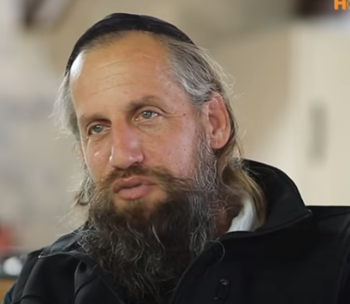
Ira Zimmerman

If there was ever a picture in the dictionary of a Jewish farmer, it would be Ira Zimmerman. From a very, very young age, he was going to work with his father in the fields. He became a tractor driver and this is what he did for a living, he would use his combine harvester to harvest fields.
Ira has a passion for using his farming skills to promote Torah and Mitzvot, which is why he volunteers his time to harvest the wheat for Matzah Shmurah every year. He also volunteers a ton of his time and efforts for Keren Hashviit, an organization that helps farmers keep the laws of Shemittah.
Seven years ago - which was the 6th year of the Shemittah cycle - it turns out that that year it rained in Israel very late into the harvesting season. All the center of Israel was no good for Matzah Shemurah and the north was also raining in the fields, so the only option left was to go to the south of Israel.

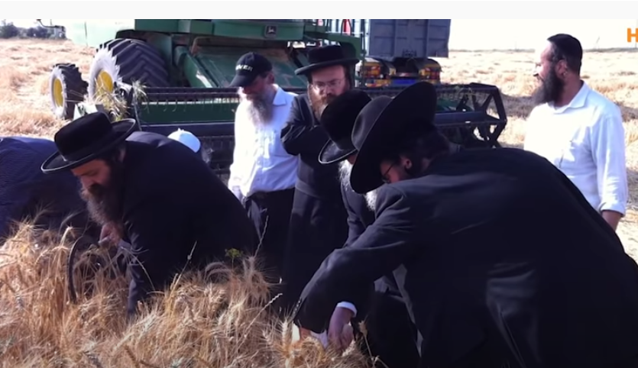
Ira on the right, supervising the harvesting the wheat for Matzah Shmurah.

Fortunately, Ira and his friends, found a field in the south of Israel, next to the Gaza border. The only problem was, that no farmer wants to work in a field next to the Gaza border. The tension between Israel and Gaza was palpable. They were at the brink of war. But then because Ira grew up in that region, he knew the region well and even though it is a little hard, a little risky, sometimes they shoot over the border and sometimes they throw stones, he decided to do it and just keep going.

It Was Getting Too Close to Rosh Hashanah
The problem is that the Kibbutznik, the owner of the farm site, said, you cannot take it now, it’s not ready yet, it’s still a little green, you need to wait another one and a half to two weeks. It was getting too close to Rosh Hashanah and the start of the Shemittah year, so Ira decided that they cannot wait as next year is Shemittah so they need double the usual amount and they were worried that the rain may come and if it starts to rain the whole field is useless, so they will take it all now.
They worked overtime from dawn to dusk from sunrise to sunset. They tried their best to harvest the field as fast as possible as they didn’t want any rain to ruin any of their chances to take the wheat to be used for Matzah Shemurah. In addition they needed double the amount of wheat they would usually harvest, this year they would need to take three thousand tons.

The Ground Beneath them Felt Like it was Shaking
While they were in the field on the tractor, Ira remembers his partners saying that he can feel the ground beneath them shaking. It felt kind of unstable. But it wasn't like something unusual because it's a field with a big truck, there are holes, it’s understandable to feel a little unstable. Within two or three days, they managed to harvest the entire field. They sent shiploads of the wheat to all the major cities in Israel for those bakeries to have for Matzah Shmurah and also to store away for next Pesach for Shmittah.

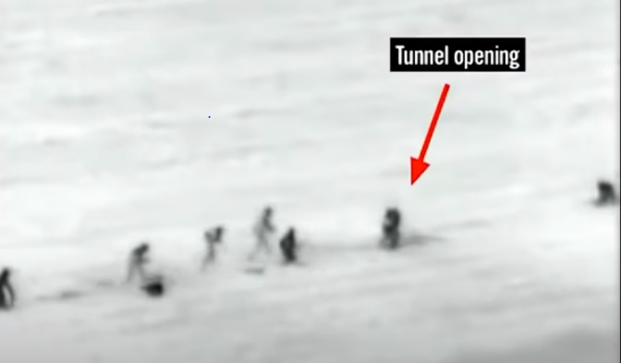
Israel Defense Forces photo showing terrorists exposed on the field that Ira Zimmerman had harvested the wheat for the Matzah Shemurah bakeries.

Two days later, that specific field was all over the news. Thirteen terrorists were caught trying to penetrate the Sufa Kibbutz. The Hamas terrorists dug a tunnel and they came up exactly where Ira and his partners were working with the combine harvester for the Matzah Shmurah. The terrorists were hoping that that week the wheat would have ripened and grown in the field so it would cover them, so they wouldn’t be seen. But because Ira and his partner risked their lives by working overtime to harvest every strand of wheat for Matzah Shmurah, and to store for the next year due to Shemittah, the terrorists were exposed right away. The Israeli Defense Force was able to see them in the cameras and right away they were able to kill them. There is only one Mitzvah that Hashem gives an explicit promise of “ברכתי את וציוויתי – He will enforce His blessing” unto those who keep the Mitzvah of Shemittah. It was thanks to the Mitzvah of Shemittah, that this miracle was able to happen.

Reprinted from the Parshat Nitzavim 5781 email of The Jewish Weekly (Israel)

‘My Thoughts Are Not
Like Your Thoughts’
By Mrs. A.S.

As a widow, my life has not been easy, especially when it comes to earning a living. There were ups and downs, but what encouraged me was a direct connection with the Creator of the World. When you consider, it is impossible not to see the hashgacha pratis with every step, and the awareness is renewed from the wisdom of Yisbarach when the salvations came in ways I never thought of.
I will tell you a story out of many in order to publicly thank Hashem Yisbarach. A few weeks before, I made a doctor’s appointment for late in the afternoon. When the day of the treatment arrived, I did not have a penny. I had already tried to raise the money for the treatment for days and I had no solution. While I was still thinking and praying for the money, I heard the sound of running water. It became clear that not only did I need money for the doctor, now I also needed money for the plumber to fix the leak. I turned off the main faucet, and I called the plumber for an estimate, and I made an appointment for that night.
I left the house in a hurry for some air, and I met a woman I had not run into in a long time. She immediately apologized and took out a sum of money from her bag and said she owed it to me for a long time and she simply forgot about it. I went home and counted the money, and it was the exact amount I needed for the doctor or the plumber.
Now I did not know what to use the money for, the treatment or the leak. I decided that whoever would come first. The plumber came and said it was the responsibility of the landlord to pay for the damages, as the leak started in the building plumbing. The landlord paid and now I had the money for the treatment. I am amazed by the hashgacha of Hashem, and I said, “I thought of many solutions, but I never thought of a solution like this.”

Reprinted from the Parshas Nitzavim 5781 email of Tiv Hakehila.

Searching for the
White Honda Civic

Known the world over as an internationally acclaimed speaker, Rabbi Berel Wein shlita, was once invited to speak at a conference in Pittsburgh, Pa. When Rabbi Wein landed at the terminal in Pittsburgh, a local Orthodox woman from the community was waiting to drive him to his hotel.
The woman said that she had a white Honda Civic, which was parked in row three, stall four. They walked through the massive airport to the parking lot. But when they arrived at row three, stall four, her car wasn’t there. They then walked
around the entire parking lot looking for the car, but there was no white
Honda Civic to be found.

The woman was very distraught and told Rabbi Wein that she would call a taxi to drive him to his hotel while she tried to figure out what to do about her car. While they were walking back to the terminal, a car pulled up alongside them. A man rolled down the window and said that he couldn’t find a parking spot, so he would gladly drive them to their car so he could take their spot.
When Rabbi Wein explained the problem, the man asked to see the parking ticket the woman received when she parked her car. She handed him the ticket, and he took one look at it and said that her car was parked in the long-term parking lot, and she was looking in the short-term parking lot.

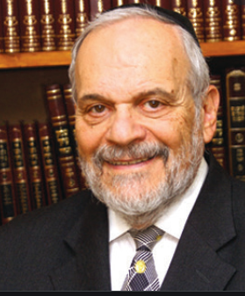
Rabbi Berel Wein

He drove them over to the long-term parking lot, and, sure enough, in row three-stall four was the white Honda Civic.
What Happened?
When they were finally on their way, the embarrassed woman asked Rabbi Wein what he thought about what had occurred. He replied that it’s a great moral lesson. Most people look for their happiness, fulfillment, and future in the short-term parking lot, but in truth, it’s parked in the long-term parking lot. The disaster of modern man is that everybody is parked in the short-term lot and fail to realize the long-term consequence of behavior, actions, and attitudes. (Rabbi Dani Staum, Monsey Mevaser)

Reprinted from the Parshas Nitzavim 5781 email of Rabbi Dovid Hoffman’s Torah Tavlin.

“Tizku L’mitzvos”

Do we understand just what life really is? Well, here’s a story about a Yid who truly understands the meaning of life. It was told by Rabbi Boruch Bodenheim shlit’a, a Rosh Yeshiva of Ner Boruch - Passaic Torah Institute (PTI). There is a Yid in Yerushalayim known as Tizku L’mitzvos (may you merit to fulfill more mitzvos). He received this nickname by spending his days raising money for poor people, saying to his donors, “Tizku L’mitzvos,” as he walks around the various shuls and yeshivos raising money.
One rainy day, my good friend Rabbi Moshe Ginian was driving in Jerusalem and saw Reb Tizku L’mitzvos standing at a street corner, totally drenched from the pouring rain. Moshe offered him a ride, which he gladly accepted.

A Chance to Find About the Man’s Unique Story
“Now is my opportunity,” thought Moshe, “to inquire about this man’s unique story - and his nickname.” They made small talk until he felt comfortable enough to ask, “Please tell me, I see you in various shuls raising money for poor people. How did you get involved in this?”
Reb Tizku L’mitzvos began his story. “I used to be a very successful electrician. A few years ago, my wife passed away. A couple of months later, I was accidentally hit by a bus and went flying, landing on my head. When I awoke, I was paralyzed. I went home weeks later, being told I’d be paralyzed for life.
When my youngest child got engaged, I gave them my apartment and moved in with one of my married children. I felt so good, so fortunate that all my children got married. Still, I couldn’t move. One day, I looked up to the heavens and said, ‘Hashem, you did not give me life for no reason. I can’t move, so what am I here for? If you give me the ability to walk again, I will dedicate my days to mitzvos; I will spend my days raising money for your needy children.’”

The Miracles Begin the Very Next Day
“The next day,” he said, “I miraculously was able to move my right arm ever so slightly and the following day my left arm; the next week my right leg and the one after that, my left leg. Slowly, very slowly, my ability to move returned. After months of intensive rehabilitation, I was able to walk and use my arms and legs again. I was fully mobile!
“So, I got on a bus and traveled around, starting to raise money to fulfill my pledge to Hashem to devote my life to doing mitzvos. Hence my refrain ‘Tizku L’mitzvos,’ as I have been raising funds for the needy over the last ten years. I have very little money of my own and I live in my married daughter’s apartment but undoubtedly, I am the wealthiest person! I feel so fortunate that all my children are married and healthy and well, and that I have constant opportunities to help the needy.”
My friend Rabbi Ginian told me he was going through a difficult period financially at the time and wasn’t sure what to do. Meeting “Tizku L’mitzvos” was a clear message from Hashem: “Don’t worry about your finances - you have wonderful children who keep Torah and mitzvos; you are the wealthiest person! This is why you are alive - Tizku L’mitzvos!”

Reprinted from the Parshas Nitzavim 5781 email of Rabbi Dovid Hoffman’s Torah Tavlin.

The Hachnasas Orchim Legacy
Of Rav Yeshaya’le Kerestirer

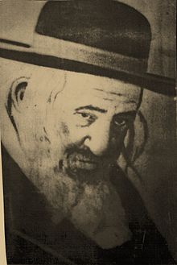

In the beginning of his leadership in Kerestir, Rav Yeshaya’le Kerestirer, zt”l, strove to excel in the Mitzvah of Hachnasas Orchim, being hospitable to guests. His house and his Shul were always prepared to receive the many Jews that visited him, and many poor and destitute attached themselves to him to be under his support. Food was always prepared for anyone hungry and needy, at all hours of the day and night.
Rav Yeshaya’le was meticulous about doing all this himself, so that Brachah should flow in his house to sustain Klal Yisroel, as is taught in the Zohar Ha’kadosh. Whoever entered Kerestir, whether it was on a weekday, or for Shabbos or Yom Tov, would benefit from Rav Yeshaya’le’s Chesed, and Rav Yeshaya’le always looked at it like he were serving a king.
Everyone knew that if they planned a visit to the Rebbe, they would not have to worry about anything physical, as all needs for eating, drinking, and sleeping were taken care of by Rav Yeshaya’le.
One year on Rosh Hashanah, during the break before Shofar blowing, Rav Yeshaya’le would distribute cookies to the congregants so that they should eat and be satisfied.
In his humility he would say, “The great Tzadikim are involved with their Kavanos for blowing the Shofar and the hidden symbolism for it, as written in the Zohar, and other holy matters, but I am a simple Jew. I am involved in helping satisfy Jewish Neshamos in the matter of, “L’Sovah V’Lo L’Razon”, “For plenty and not for scarcity!”

Reprinted from the Rosh Hashanah 5782 email of Rabbi Yehuda Winzelberg’s Torah U’Tefilah.

The Doctor and the
Higher Authority

Rav Paysach Krohn relates a story. There was a young man in his early forties who was very, very sick, R”L. He had a wife and a few children. The doctor told his worried wife, “I cannot take the chance to operate unless you get me a higher authority of somebody who says that I can operate on this man. I am afraid that he will die on the operating table.”
The doctor meant that she should find a bigger doctor, perhaps a university doctor from a more prestigious hospital to take responsibility. She thought, however, “Who is the highest authority that I know?”
She remembered that when her husband was twenty years old, he learned in Yeshivah Tiferes Yerushalayim, under Rav Moshe Feinstein, zt”l. She decided to go visit Rav Moshe and ask him what to do.
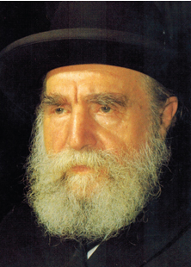
A few days later, the doctor called and asked her, “Did you go to a higher authority?”
She calmly answered, “I’m going tomorrow.” Curious, he inquired, “Which doctor are you going to?”
She explained, “I’m not going to a doctor. I’m going to a Rabbi.” The doctor exclaimed, “I don’t believe it! You’re going to ask a rabbi whether I should do a medical procedure?! The Rabbi must know medical background. What are you wasting your time for?!”
Confident, she replied, “You asked me to see a higher authority. This is who I consider the highest authority.”
Astounded, he made an interesting request, “Can I go with you when you approach the Rabbi? I need to see this with my own eyes. I don’t believe that a Rabbi without any medical background will be able to make such a decision.”
She agreeably answered, “Come along. I’m going tomorrow with my father, and you can join us.”
Sure enough, they went to Rav Moshe’s apartment, and Rav Moshe welcomed the group in. He spoke to them and inquired about the seriousness of the illness and the details of the operation.
He then said to the wife, “I’m trying to remember your husband. You told me that he learned in my Yeshivah twenty years ago.”
She said, “Rosh Yeshivah, I have a picture of what he looked like twenty years ago in your Yeshivah.” She pulled out a picture for Rav Moshe to see.
When Rav Moshe saw the picture, he recognized the boy, and he started to cry. The doctor, who now saw Rav Moshe’s genuine care and concern with his own eyes, turned to the wife and said, “Now I understand why a Rabbi can make such a decision. A person who can cry over somebody else’s illness like this, and this is someone he hasn’t seen in twenty years, G-d will help him make the right decision.”
Rav Moshe then instructed that the operation should take place, but together with that, the sick man should make a Kabalah, and accept something on himself. He should undertake that from then on, every Brachah that he says should be said out loud, so that somebody could hear and answer ‘Amein’.
Rav Moshe explained that the Gematria, numerical value, of the word ‘Amein’ is 91. The Gematria of the word ‘Malach’, angel, is also 91. Every time a person says a Brachah and somebody responds ‘Amein’ to it, he creates a Malach, and these Malachim protect us. Rav Moshe said, “The man should undergo the operation armed with the Kabalah of saying Brachos out loud. He should also tell other people to say Brachos out loud, so that he could answer Amein. Others will also say Amein to his Brachos, and with that, he will be creating many Malachim, which will protect him.”
The family did as they were instructed, and the operation was successful. This man went on to live many years after the operation. By saying his Brachos out loud and answering Amein to others, he created many protective Malachim for the rest of his life!

Reprinted from the Parshas Nitzavim 5781 email of Rabbi Yehuda Winzelberg’s Torah U’ Tefilah

Who Will Replace Our Precious Lost Children?

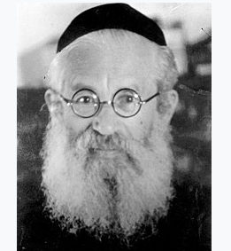

Rabbi Isaac Herzog, ZT”L, once visited Chicago following World War II. The entire Torah-revering community gathered at the airport. All the day schools and Yeshivos sent their students to greet the Rabbi, and many prominent lay leaders left their businesses to join as well.
Rabbi Herzog, his distinguished frame, unbent from the enduring pain of the plight of his brothers and sisters, in Europe and Palestine, walked upstanding and tall down the silver airplane steps, his silver-tipped cane in one hand, his head majestically adorned with his signature top hat.
He was led to a podium from which he delivered a lecture on a complicated portion of the Gemara. When he finished, his face lost its radiance, and became somber and staid.
“I come not from Jerusalem,” he told the assembled, “I come from Rome. I have just met with Pope Pious.”
“During the terrible war, many children were sheltered in monasteries. The Christians saved them from the Nazis. I asked him to release those children back to their heritage and be raised as Jews.” Suddenly, to the shock of all those present, the Rabbi began to cry. “The Pope did not acquiesce. He said that once a child is baptized, he can never be returned. Rabbi Herzog sobbed. uncontrollably. He looked at the assembled children. “My dear children,” he wailed, “We lost them! Then his demeanor changed, as a ray of hope sparkled from his eyes. “We lost them,” he repeated, “but we have you! WE HAVE YOU!” (Story heard from Rabbi Berel Wein).

Reprinted from the Parshas Nitzavim 5781 email of Reb Mendel Berlin’s Torah Sweets Weekly.

The Jewish Baby who Grew Up to Become a Priest – And Then Returned to Judaism
On a winter night in 1943, a young, frightened woman knocked on the window of the Vashkinel home in a small town not far from Vilna.
The woman quickly handed Amelia Vashkinel a small, tightly wrapped bundle containing a baby, who was just a few days old. That night was preceded by several secret meetings held between Amelia and Batya, the baby’s mother, who knew she had been sentenced to death and wanted to save her son.
With the Holocaust at its peak, Amelia was afraid to take in a Jewish baby and raise him. She explained to the mother that if it became known that he was Jewish she would be put to death. But Batya, determined to save her son at all cost, told Amelia: “You are a Christian. When he grows up he’ll be a priest and a teacher.”

The Mother Debated the Decision to Give Away Her Baby
Amelia hesitated, weighing the pros and cons of taking in the baby, and in the end decided to give life to the helpless baby in her arms.
Batya whispered the child’s name and disappeared into the darkness. “You had a very Jewish family name,” the adoptive mother told her son, when she revealed the secret to him 35 years later. “But I very quickly forgot it. I was afraid it would be a death sentence. And so I didn’t want to remember anything from that night.”
This is the story of that child, Yaakov, whose life has taken many turns. He discovered conclusively that he was a Jew when he was a senior priest in Poland. In recent years, however, his life has come full circle.

Yad L’Achim has been at Yaakov’s side during this process, sometimes directly and sometimes indirectly. It provided him with sacred Jewish objects, and more. Recently, an extraordinary meeting was held between Yaakov and Rabbi Chanoch Gechtman, head of Yad L’Achim’s counter missionary department.

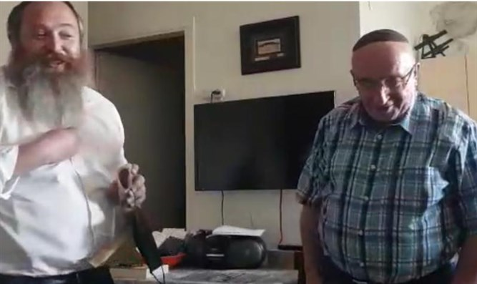
Yaakov and Rabbi Chanoch Gechtman (Photo by Yad L’Achim)

At the meeting, Yaakov was moved by the sound of the shofar, which he compared to the deep cry of a long-lost son returning to his father.
“This is my story, the baby that was taken captive,” Yaakov responded with great emotion.
Everyone in the room was moved by the sight of an 81-year-old Jew who had lost his Jewish identity as a baby during the Holocaust, returning to his people.
Yaakov added: “Look at how amazing things turned out. Hashgacha [divine providence] arranged things such that from a young age I was a teacher and then a priest. I never married, which means I never married a non-Jew, and I never had non-Jewish children. I imagine that had things worked out differently, it would have been much more difficult for me to leave everything and return to the religion of my fathers.”
Yaakov now lives in Jerusalem and works for Yad Vashem. He continues to enjoy a warm connection with Yad L’Achim

Reprinted from the September 10, 2021 email of Arutz Sheva
The True Defenders of Israel

From the moment of the State of Israel’s birth, the army has occupied a central role in society. In 1948, with the country in the throes of its War of Independence, the interim government ordered the establishment of one unified military that was called Tzvah Hagannah L’Yisrael - abbreviated to Tzahal - Hebrew for “Israel Defense Forces.”
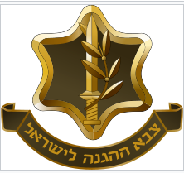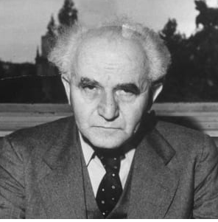Prime Minister David Ben-Gurion
Israeli Prime Minister David Ben-Gurion, urged by Torah leaders of the generation and motivated by a desire to avoid political conflict with the ultra-orthodox, as well as to help revive the Charedi community which were decimated by Holocaust, agreed to an exemption of military service and the draft, for those who learn Torah and study in yeshivah full-time. Unfortunately, this has been a constant point of contention between secular and religious Israelis.
In 1968, the Israeli government under Prime Minister Levi Eshkol, appointed a commission to reconsider the draft exemption provided to yeshivah students. It was immediately after the Six-Day war and many Israelis, including quite a few government officials, were of the opinion that the original exemption agreed upon by Ben-Gurion, should not be continued.
As a result, they pushed with considerable pressure and influence to see this matter reconsidered. Numerous meetings were held and, like most issues in the Knesset, a contentious debate erupted. R’ Yechezkel Abramsky zt”l, as president of the “Va’ad HaYeshivos” was invited to address the commission.

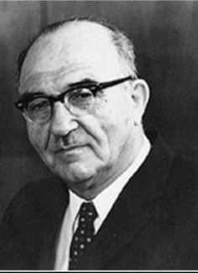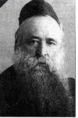
Prime Minister Levi Eshkol Rabbi Yechezkel Abramsky

Midway through his speech, one of the government ministers stood up and rudely interrupted R’ Abramsky. “Rabbi, let me ask you a question. Doesn’t your honor agree that actively defending the country of Israel, is more important and serves more of a purpose than just sitting around in a room and studying the Torah?”
R’ Yechezkel was unruffled and immediately answered the brazen minister. “The words in the beginning of Sefer Yehoshua prove the supremacy of Torah,” R’ Yechezkel responded. “We read that Hashem gave Yehoshua two commandments: to conquer the land and to study and keep the Torah.
Regarding the first, Hashem said, - ’Be strong and courageous for you will inherit the Nation and take over the land.’ Regarding the latter, however, Hashem added a word to his missive. - ’Be very strong and courageous in order to keep the whole Torah which My servant Moshe commanded you.’”
R’ Abramsky looked hard at the minister and then swept his gaze around the room. “Note,” concluded R’ Yechezkel, “in which case Hashem added the emphasis - ‘very’. It is by the express commandment to protect the integrity of the Torah, to study it and to keep its mitzvos. Obviously, the lesson is clear: It is more important in the eyes of G-d to defend the Torah and those who learn and fulfill it, for by doing so, we are in fact exhibiting the greatest defense of the Nation and the Land of Israel!” R’ Yechezkel’s heartfelt words made their mark on all those present and the motion was shelved.

Reprinted from the Parshas Vayeilech 5782 email of Rabbi Dovid Hoffman’s Torah Tavlin.

